Chapter 8: Computer Aided Software Engineering
8.1. Overview of CASE Approach
• Computer Aided Software Engineering (CASE) is the use of computer-based support in the software development process.
• Embedding CASE technology in software process led improvements in software quality and productivity.
CASE Automated Activities
• The development of graphical system models.
• Understanding a design using a data dictionary
• Generation of user interfaces
• Program debugging
• The automated translation of programs from an old version
CASE Limited Factors
• Providing artificial intelligence technology to support design activities will be unsuccessful.
• Software engineering is a team based activity that require interactivity among team members. CASE technology does not support for this.
8.2. Examples of CASE tools
CASE Tools
• Tools used to assist the all aspects of the software development lifecycle are known as CASE Tools.
• Some typical CASE tools are:
– Code generation tools
– Data modeling tools
– UML
– Refactoring tools
– QVT or Model transformation Tools
– Configuration management tools including revision control
CASE Classification
• Help to understand the types of CASE tools and their role in supporting software process activities.
• CASE tools can be classified in three perspectives.
– Functional perspective: Classify according to the specific function.
– Process perspective: Classify according to the process activities that they support.
– Integration perspective: Classify according to how they are organized into integrated units that provide support for one or more process activities.
Functional Classification of CASE Tools
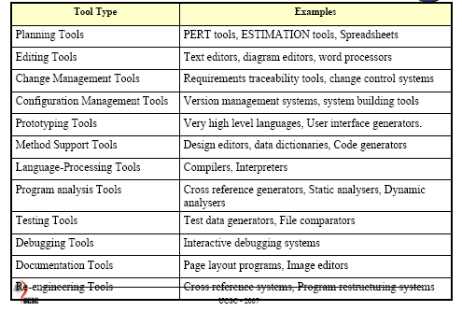

Another Classification Dimension
• CASE tools can be classified according to the support offered to software process.
– Tools : Support individual process tasks such as checking consistency of a design etc.
– Workbenches : Support process phases or activities such as specification etc.
– Environments : Support all or substantial part of the software process
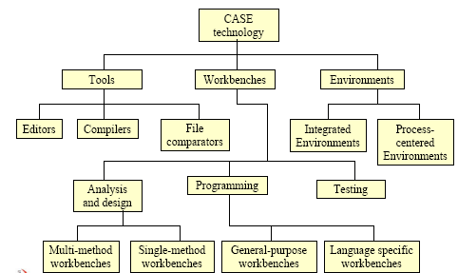
Tools Workbenches and Environments

